

**The University of Central Punjab**

**Faculty of Information Technology**

**Department of Data Science**

**BS-DS-F24-DA1**

PROJECT DOCUMENTATION

**Click and Collect**

**Sales management System**

**For an Electronics Store**

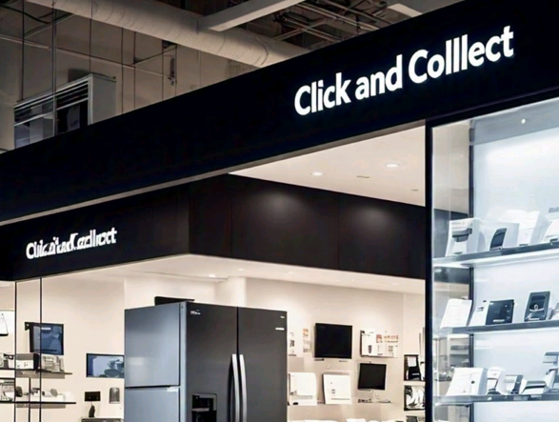

Table of Contents

1. Introduction of Project 4

1.1. Project Overview 4

1.2. Objectives of Project 4

1.3. Scope of Project 4

2. System Requirements 5

2.1. Hardware 5

2.2. Software Requirements 5

3. Project Features 6

3.1. Product Deals: 6

3.2. User Records: 6

3.3. Easy Product Selection: 6

3.4. Generating Bills: 6

3.5. Admin Records: 6

3.6. Search Functionality: 6

4. System Design 7

4.1. System Architectural Diagram 7

4.2. Flow Chart for Processing 8

4.3. ER Diagram of Program 9

5. User Interface 10

5.1. Customer Information 10

5.2. Product Categories 10

5.3. Admin Record 11

6. Implementation Details 12

6.1. Pseudocode For Program 12

7. Testing 16

7.1. Testing Cases & Results 16

Case 1: User Information 16

Case 2: Categories of Items 16

Case 3: Products in Each Category 17

Case 4: Brands Selection 17

Case 5: Product Specifications 18

Case 6: Add to Cart & Continue Shopping 18

Case 7: Multi-Products Selection 19

Case 8: Payment Processing 19

Case 9: Bill Slip 20

Case 10: Admin Processing 20

Case 11: Sales Report 21

Case 12: Stock’s View 21

Case 13: Restock of Products 22

Conclusion 22

Summary Of Project: 22

Developed by 23

4

# 1. Introduction of Project

## 1.1. Project Overview

This project introduces a tablet-based system using a custom **Click and Collect Sales Managing Software** for electronics stores. The software allows customers to browse products, check prices, and view availability independently, reducing the need for staff assistance. Tablets are placed in the store or handed to customers at the entrance.

The software tracks sales in real time, enabling managers to monitor performance and generate reports easily. It also highlights promotions and related products to enhance the shopping experience. This solution improves service, reduces wait times, and simplifies sales management.

## 1.2. Objectives of Project

* Save customers' time by providing quick access to product information.
* Reduce the need for workers to assist with basic queries.
* Improve the efficiency of sales tracking and reporting.
* Enhance the shopping experience with personalized recommendations.
* Auto counting and bill generating
* Increase accessibility by using tablets across the store.
* Automate real-time sales data collection and monitoring.
* Boost sales by promoting

## 1.3. Scope of Project

This software is important for electronics stores because it improves customer satisfaction by making shopping faster and more convenient. It reduces the need for staff, cutting down operational costs. Managers get valuable insights from real-time sales data, which helps in making informed decisions and optimizing inventory. By promoting special deals and related products, the software can boost sales and keep customers more engaged. Overall, it gives stores a competitive edge by enhancing service efficiency and simplifying sales management.

# 2. System Requirements

## 2.1. Hardware

* **Tablets:**

Provide multiple tablets for customers to browse products, check prices, and see availability.

* **Server:**

A powerful server with at least 8GB RAM and 500GB storage to manage sales data and software operations.

* **Wi-Fi Access Points:**

Set up several Wi-Fi access points to ensure strong internet connectivity throughout the store.

* **Point of Sale (POS) Terminals:**

POS terminals that work seamlessly with the software, including barcode scanners and receipt printers.

* **Backup Power Supply:**

Use UPS units to protect against data loss during power outages by providing backup power to servers and network equipment.

## 2.2. Software Requirements

Having the software on all tablets ensures that every customer can independently browse products, check prices, and view availability, enhancing their shopping experience.

With the software installed on all tablets, customers receive the same user experience regardless of which tablet they use. This consistency is important for maintaining high customer satisfaction.

# 3. Project Features

## 3.1. Product Deals:

Shows special deals and promotions to customers, making their shopping experience better and encouraging them to buy more.

## 3.2. User Records:

Keeps track of customer interactions, purchases, and feedback to help improve services.

## 3.3. Easy Product Selection:

Allows customers to easily browse and select products, making the shopping process quick and easy.

## 3.4. Generating Bills:

Automatically creates bills and receipts for purchases, making checkout smooth.

## 3.5. Admin Records:

Maintains detailed records for store managers, including sales data, inventory levels, and customer feedback, to help manage the store efficiently.

## 3.6. Search Functionality:

Includes a powerful search feature that helps customers quickly find specific products by name, category, or specifications.

# 4. System Design

## 4.1. System Architectural Diagram

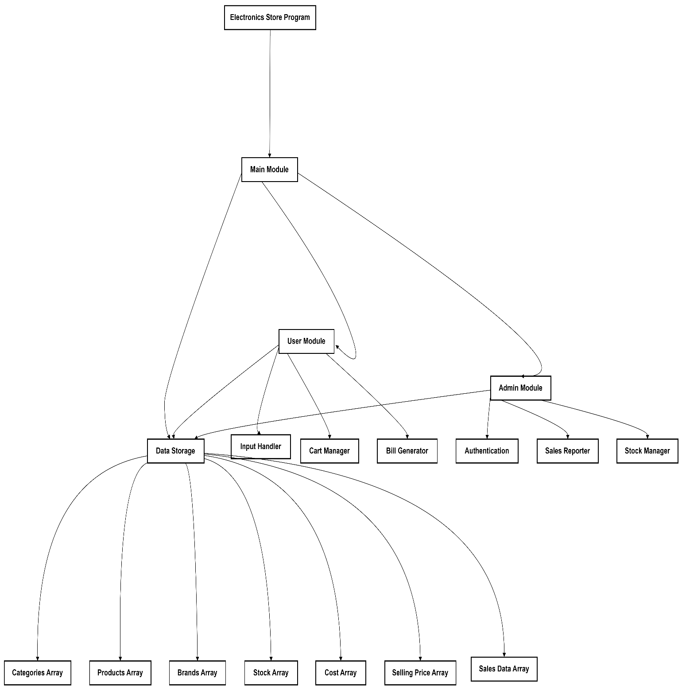

## 4.2. Flow Chart for Processing

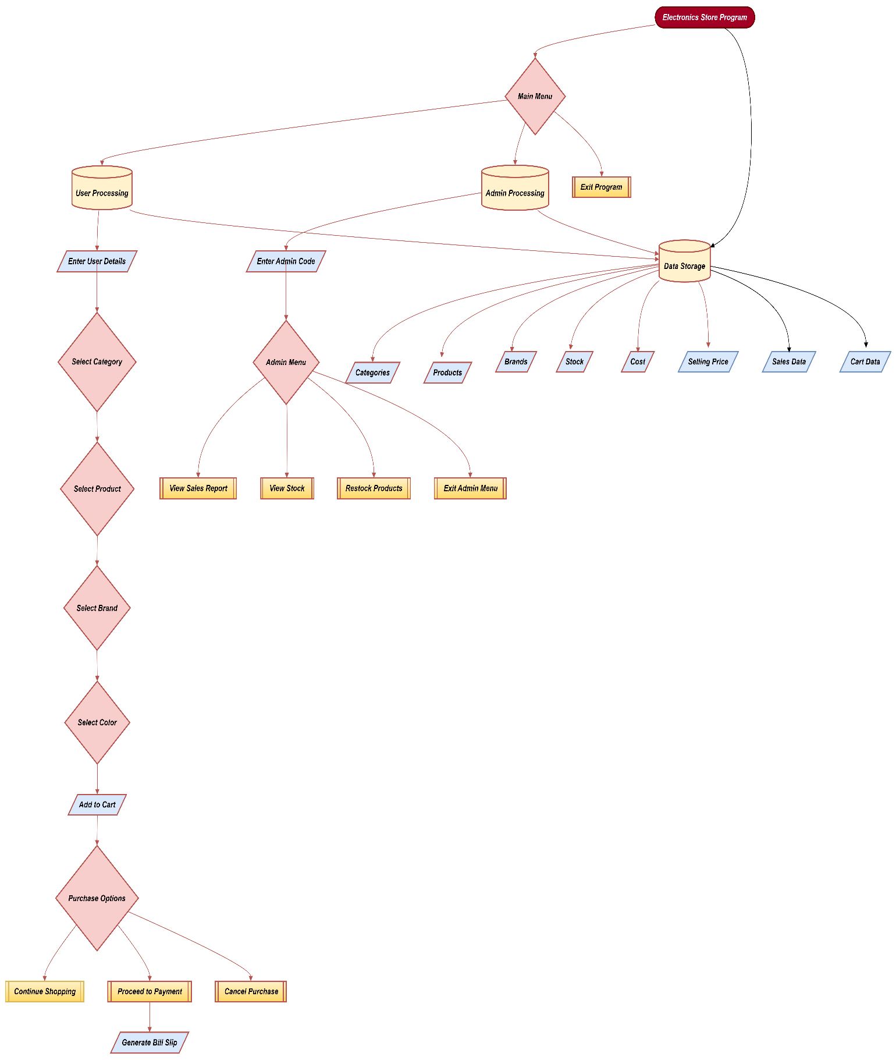

## 4.3. ER Diagram of Program

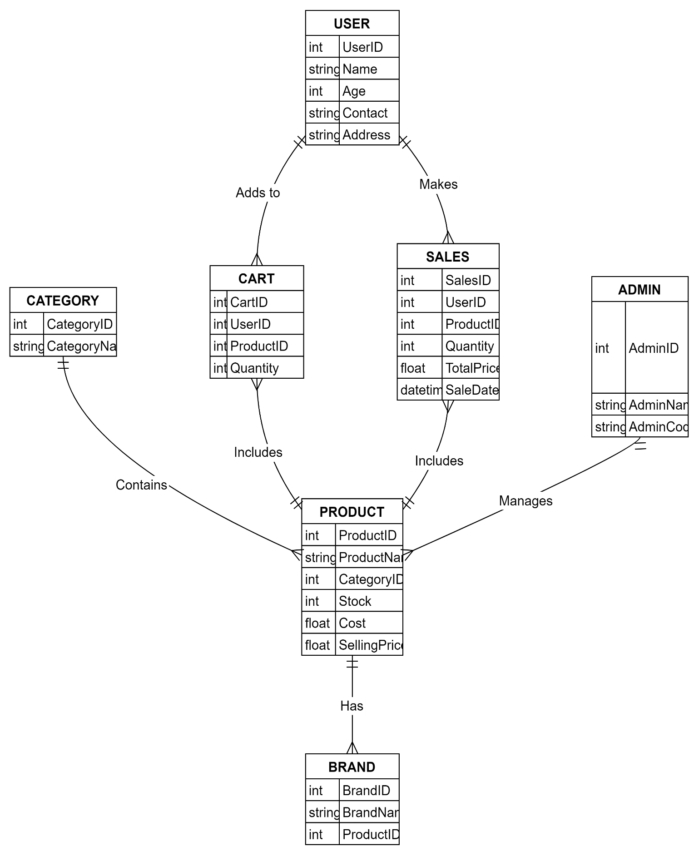

# 5. User Interface

## 5.1. Customer Information

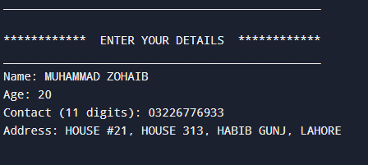

## 5.2. Product Categories

1.Main Categories:

2.Products In Main category:

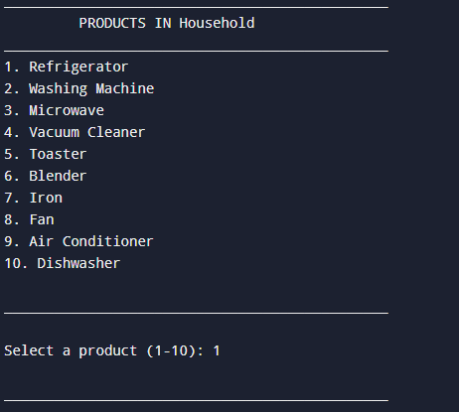

## 5.3. Admin Record

# 6. Implementation Details

## 6.1. Pseudocode For Program

FUNCTION RestockProducts()

**BEGIN**

User information

Display Categories:

Show all categories

GET categoryChoice

Display Products in Selected Category:

Show all products in the category

GET productChoice

GET newStock

IF newStock >= 0 THEN

Update Stock:

stock[categoryChoice][productChoice] = newStock

Display "Stock updated successfully!"

ELSE

Display "Invalid stock quantity. Stock not updated."

END IF

**END Initialize Arrays**:

categories = ["Household", "Industrial", "Personal", "Gaming", "Entertainment"]

products = 2D array of products for each category

brands = 3D array of brands for each product

stock = 2D array of stock levels for each product

cost = 2D array of cost prices for each product

sellingPrice = 2D array of selling prices for each product

salesData = [] // To store completed sales

cart = [] // To store items in the user's cart

WHILE programRunning DO

Display Main Menu:

1. User Processing

2. Admin Processing

3. Exit Program

GET userChoice

IF userChoice == 1 THEN

CALL UserProcessing()

ELSE IF userChoice == 2 THEN

CALL AdminProcessing()

ELSE IF userChoice == 3 THEN

programRunning = False

ELSE

Display "Invalid choice. Please try again."

END IF

END WHILE

END

**FUNCTION UserProcessing()**

BEGIN

GET userDetails:

Name, Age, Contact, Address

Validate userDetails:

- Name: Alphabets and spaces only

- Age: Between 15 and 100

- Contact: Exactly 11 digits

- Address: At least 10 characters

WHILE continueShopping DO

Display Categories:

IF Age < 18 THEN

Display only Personal, Gaming, Entertainment

ELSE

Display all categories

GET categoryChoice

Display Products in Selected Category:

Only show products with stock > 0

GET productChoice

Display Brands for Selected Product

GET brandChoice

GET colorChoice

Add Product to Cart:

cart.append({

Product: products[categoryChoice][productChoice],

Brand: brands[categoryChoice][productChoice][brandChoice],

Color: colorChoice,

Price: sellingPrice[categoryChoice][productChoice]

})

**Update Stock:**

stock[categoryChoice][productChoice] -= 1

Display Cart:

Show all items in cart with total price

Display Purchase Options:

1. Continue Shopping

2. Proceed to Payment

3. Cancel Purchase

GET purchaseOption

IF purchaseOption == 1 THEN

continueShopping = True

ELSE IF purchaseOption == 2 THEN

CALL GenerateBill()

continueShopping = False

ELSE IF purchaseOption == 3 THEN

Clear Cart

continueShopping = False

END IF

END WHILE

END

**FUNCTION GenerateBill()**

BEGIN

Calculate Total Price:

totalPrice = sum of all items in cart

Apply Discounts:

IF totalPrice > 500000 THEN

discount = 10%

ELSE IF totalPrice > 300000 THEN

discount = 8%

ELSE IF totalPrice > 100000 THEN

discount = 5%

ELSE

discount = 0%

END IF

discountedTotal = totalPrice * (1 - discount)

Display Delivery Options:

1. Pick Up

2. Home Delivery (Rs. 2000 extra)

GET deliveryOption

IF deliveryOption == 2 THEN

discountedTotal += 2000

END IF

**Display Payment Options:**

1. Digital Payment

2. Cash Payment

GET paymentOption

Generate Bill Slip:

Display User Details

Display Items in Cart

Display Total Price

Display Discount (if any)

Display Delivery Charges (if any)

Display Final Total

Update Sales Data:

salesData.append({

User: userDetails,

Items: cart,

Total: discountedTotal,

Date: currentDate

})

Clear Cart

END

**FUNCTION AdminProcessing()**

BEGIN

GET adminCode

IF adminCode == 4321 THEN

WHILE adminMenu DO

Display Admin Menu:

1. View Sales Report

2. View Stock

3. Restock Products

4. Exit Admin Menu

GET adminChoice

IF adminChoice == 1 THEN

Display Sales Report:

Show all entries in salesData

ELSE IF adminChoice == 2 THEN

Display Stock:

Show stock levels for all products

ELSE IF adminChoice == 3 THEN

CALL RestockProducts()

ELSE IF adminChoice == 4 THEN

adminMenu = False

ELSE

Display "Invalid choice. Please try again."

END IF

END WHILE

ELSE

Display "Incorrect admin code. Access denied."

END IF

END

**FUNCTION RestockProducts()**

BEGIN

Display Categories:

Show all categories

GET categoryChoice

Display Products in Selected Category:

Show all products in the category

GET productChoice

GET newStock

IF newStock >= 0 THEN

Update Stock:

stock[categoryChoice][productChoice] = newStock

Display "Stock updated successfully!"

ELSE

Display "Invalid stock quantity. Stock not updated."

END IF

END

# 7. Testing

## 7.1. Testing Cases & Results

### Case 1: User Information

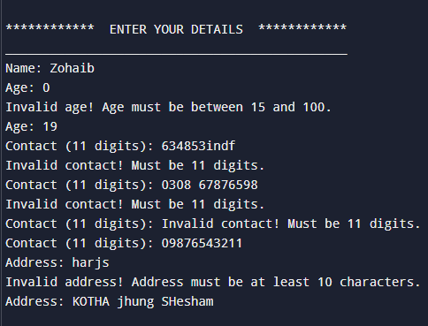

### Case 2: Categories of Items

### 

### Case 3: Products in Each Category



### Case 4: Brands Selection

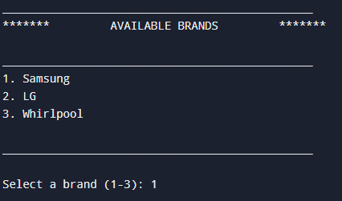

### Case 5: Product Specifications

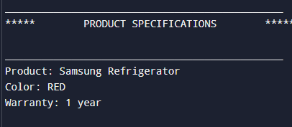

### 

### Case 6: Add to Cart & Continue Shopping

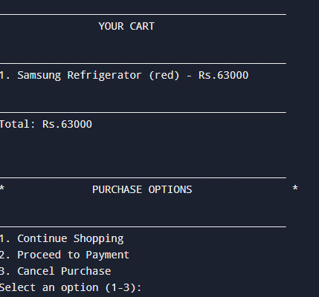

### Case 7: Multi-Products Selection

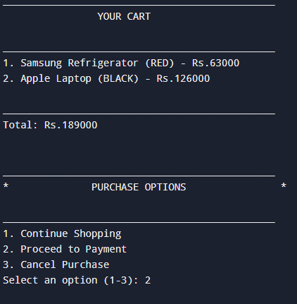

### Case 8: Payment Processing

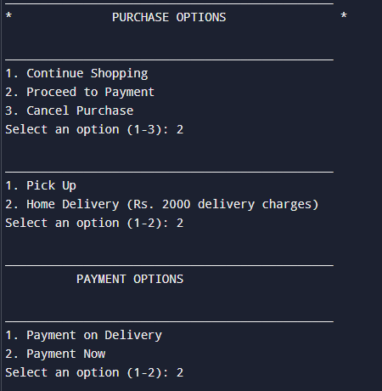

### Case 9: Bill Slip

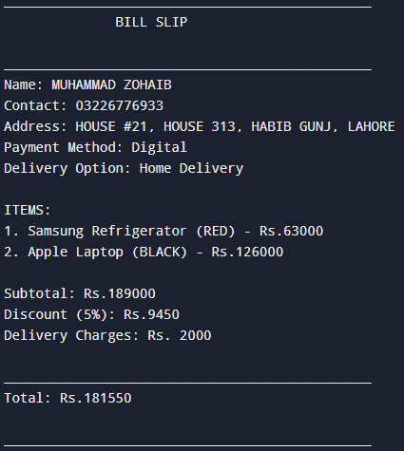

### Case 10: Admin Processing

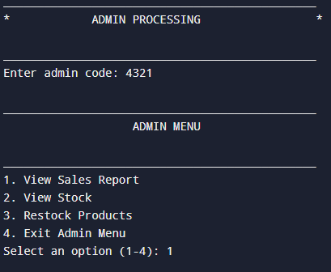

### Case 11: Sales Report

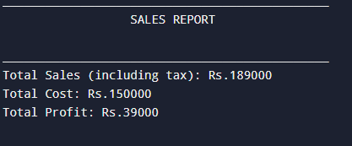

### Case 12: Stock’s View

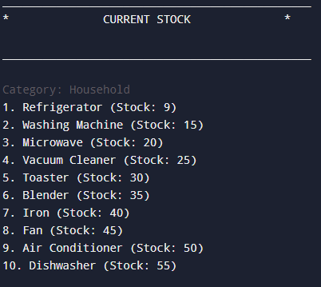

### Case 13: Restock of Products

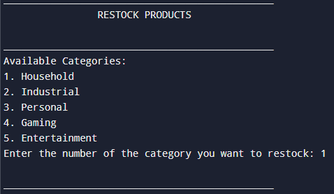

# Conclusion

## Summary Of Project:

This project provides an easy and modern solution for electronics stores using tablets with custom software. It helps customers browse products, check prices, and see offers on their own, reducing the need for staff.

The system tracks sales in real time, making it easier for managers to monitor and manage daily reports. It saves time, improves customer service, and boosts sales. By adopting this technology, the store stays competitive and offers a better shopping experience, helping the business grow.

# Developed by

|  |  |
| --- | --- |
| GHULAM FARID | L1F24BSDS0020 |